

American International University-Bangladesh (AIUB)  
**Department of Computer Science  
Faculty of Science &Technology (FST)  
Fall 22-23**

**D-PROCESS SHOPPING CART**

Software Requirement Engineering

Sec: **B**

Project submitted

By

|  |  |
| --- | --- |
| Name | ID |
| Nafisa Binte Shahadat | 19-40789-2 |
| Kashifa Efaj Mahe | 19-40197-1 |
| Abdur Rahman Swapnil | 18-38950-3 |
| Ummey Habiba Bristy | 19-40233-1 |

**Checked By Industry Personnel**

Name: Mahedi Hassan

Designation: Assistant Project Manager

Company: Apsis Software LTD.

Sign:

Date:

**Table of the Contents**

Version History 3

1. PROBLEM DOMAIN 3

1.1 Background to the Problem 3

1.2 Solution to the Problem 4

1.3 System Specification: 4

1.4 Scope of work 5

1.5 Out of scope 5

2. SOLUTION DESCRIPTION 5

3. SOCIAL IMPACT 11

4. DEVELOPMENT PLAN AND PROJECT SCHEDULE 13

5. MARKETING PLAN 15

6. COST AND PROFIT ANALYSIS 18

7. REFERENCES 21

# **Version History**

|  |  |  |  |  |
| --- | --- | --- | --- | --- |
| **Version No** | **Updated By** | **Description** | **Update date** | **Reviewed By** |
| 1. | Nafisa | Systems’ Features Specification | 1st Dec 2022 |  |
| 2. | Mahe | Modify UML Diagrams | 1st Dec 2022 |
| 3. | Swapnil | Describing Social Impact | 5th Dec 2022 |
| 5. | Bristy | Background and Solution | 6th Dec 2022 |
| 6. | Nafisa | Marketing Plan Details | 10th Dec 2022 |
| 7. | Mahe, Swapnil, Bristy | Cost and Profit analyze | 11th Dec 2022 |
| 8. | Nafisa | Project Plan Re-Schedule | 12th Dec 2022 |

# **PROBLEM DOMAIN**

## **Background to the Problem**

* In supermarkets or shopping malls, there are multiple cash counters. People gather their wanted things in a trolley or basket and go to the cash counter for checking out by paying money. And in counter, a cashier scans products bar code one by one manually and finally informs the total price including vat. Sometimes, at this moment customers notice if they are carrying enough cash or not and might be willing to skip some products. Also, this scanning process manually is very time consuming. So, most of the time it is over-crowded in front of these counters and other customers have to wait in a queue for a long time. For solving all these problems, a self-service process can be invented. Like a single trolley is a single counter and also it shows the total price of the specific customer including vat.
* Supermarkets are popular enough worldwide. In Bangladesh, weekly or monthly grocery items of many houses come from supermarkets. And also in everyday basis, supermarket is a place which is always servicing people. So, it is very related to everyday life. By making this cashing and payment system digital, this shopping process will become fast, more comfortable, efficient. Also in many other countries, self-payment is available in markets. But fully digital cart is not available. This system not only make the shopping system easy for the customers but also less the employee salary for supermarket. Because if this system is available, no more cashier or cash counter will be needed.

### **Solution to the Problem**

* For solving the problems mentioned above and making more effaceable environment in super market we want to provide a software-based trolley which will be more like an individual cash counter for an individual customer. And this product also includes an automated payment service in every exit door. This solution is appropriate for solving the problems because with the help of these products a supermarket or shopping mall can make themselves fully automated. And obviously a better-quality software provides a reliable service to customers by showing them total price including vat and other charges. This software-based trolley can meet the business object in market and also give profit to the supermarkets.
* This product is like an individual bar code scanner with a small screen which shows the total product list and total price. In every trolley this product is attached. When a customer put a product in the trolley, it instantly scans the product name and total price. And these details are shown in the screen. How many products customers add, it simultaneously scanning and adding with the existing price. After adding all the prices, it shows the total price including vat. So, customers are aware of the total cost at the right time. They don’t need to go to counter with the product collection and don’t even need to pay in the counter. Rather they will go to the exit doors with the trolley and there is another scanner which only read the total price with specific trolley number. That is the payment machine of the system. This machine reads the price value and show the total price to customers with the expectation of collecting the money. In this machine, there are three types of payment method. One is credit or debit card; another one is mobile banking and last one is cash. So, there is a small box like as ATM machine, there customers will put their credit card or cash. After receiving the money, if it is more than the total amount, this machine will provide the changes another hole (like in ATM machine where money comes out). And at last customers will get all the products in a plastic bag or there can be an employee who will help customers for putting the products in the bag.
* In 2015, this smart shopping cart is designed by 21-year-old student Bhargav Sridhar. Also, this idea is partially installed in some country, like Seoul in South Korea, UK. In this year, around March and April, Philippine claimed that they are using this Technology in some supermarket.

#### **System Specification:**

|  |  |
| --- | --- |
| **Components** | **Minimum Requirements** |
| Software Specification | |
| Solution Type | Web Application |
| Programming Language | Microcontroller in C++ |
| Database | My SQL |
| Browser Compatibility | Internet Explorer  Google Chrome  [Desktop and laptop browser only] |
| Server Specification | |
| Operating System | Micro-Controller Operating Systems (MicroC/OS) |
| Database Server | My SQL |
| Web Server | Apache |

##### **Scope of work**

* Proper scanning products’ tag
* read the product details with price
* Provide proper removing option
* Get the total price slip

###### **Out of scope**

* Vendor Payment

## **SOLUTION DESCRIPTION**

### **System Features**

**2.1.1 Functional Requirement:**

**Scanning**

|  |  |  |  |
| --- | --- | --- | --- |
| **SL No** | **Field Name** | **Field Type** | **Description** |
| 1. | Read Bar Code | String and Float | Show the price extracting from database |
| 2. | Add Price | String and float | Adjust the price by adding previous prices. |
| 3. | Count | Integer | Count all the products |
| 4. | Finish | Floating | Count the total value with vat. |
| 5. | Delete | String and Float | Adjust the total price when any product is out of the trolley |

Product’s prices are scanned instantly when customers put the product in the trolley.

**Impact on the system:**

* Customers will be able to see product’s details, product price, quantity, and vat.

**Removing**

|  |  |  |  |
| --- | --- | --- | --- |
| **SL No** | **Field Name** | **Field Type** | **Description** |
| 1. | Remove item | String and Float | Adjust the total price when any product is out of the trolley |

Products and product’s quantity can be removed from trolley.

**Impact on the system:**

* Click on ‘Remove’ option customers can remove any product from trolley.
* After remove, customers will be able to see new total price.

**Operating system of the product**

|  |  |  |
| --- | --- | --- |
| **SL No** | **Technology Name** | **Description** |
| 1. | Computer Vision Algorithm | Describe how the system will work |
| 2. | Motion Sensor Technology | Count the total things, add and remove products. |
| 3. | RFIT (Radio Frequency identification Technology) | will read the purchasing product information on the shopping cart |
| 4. | Product Identification Device (PID) | contains a microcontroller |
| 5. | Microcontroller (8052) | contains a microcontroller |
| 6. | LCD | information about the product is displayed on it and it is interfaced to the microcontroller |

System will work on the principle of computer vision algorithm, motion sensor technology, LCD, RFIT (Radio Frequency identification Technology) and system will run in microcontroller.

**Impact on the system:**

* Developer develops the system software; this system software is the interface between the hardware and user applications.

**Automated Payment System:**

|  |  |  |
| --- | --- | --- |
| **SL No** | **Technology Name** | **Description** |
| 1. | Scanner | Read the total price from the trolley LCD |
| 2. | ZIGBEE Module | Transfer the details prices to the payment microcontroller |
| 3. | Sensor | Accept the money |
| 4. | Microcontroller (8052) | Count the Money |
| 5. | Change | Return the changes |

Payment machine will scan the individual trolley screen and show the total price to the customers. Customers can pay money by using the machine. This machine accepts the money, count the total money and match it with the total price. If money is less than total price it will show how much extra money will be needed. And if the money is more than the total price, it will provide the changes to the customers.

**Impact on the system:**

* Customer’s will be able to save their valuable time
* Quick process, reduce the long queues of customers.

**Components:**

|  |  |
| --- | --- |
| **SL No** | **Components Lists** |
| 1. | RFID Reader |
| 2. | Wireless Networking |
| 3. | POS unit |
| 4. | Smart Card |
| 5. | Power Supply |
| 6. | Embedded Architecture |

For this whole system’s some initial components are: RFID system, Wireless Networking, Smart card, POS unit, Smart Card, Power supply, Software.

**Impact on the system:**

* Manages the basic operations of this system.

**2.1.2 Non-Functional Requirements (Quality Attributes):**

* **Correctness:** When customers put any product in the trolley, scanner instantly recognizes the correct product and show the correct value of the specific product.
* **Efficiency:** At least 25 percent of the processor capacity and RAM available to the application shall be unused at the planned peak load conditions.
* **Integrity / Security:** During automated payment system, customers card’s information is maintained in high privacy control. In every time, any customer at the payment machine is totally blinded about previous customers record.
* **Usability:** If a customer comes to use this smart shopping system for the first time, there will be provided an instruction chart in every trolley screen. By reading this instruction, any customers can understand the process within 3 mins. And when a customer, put any product in the trolley, the scanner scans the tag or bar code and shows the information within 4seconds (max). whole payment procedure takes only 5minutes (if there is all ok with customers card/ mobile banking balance/ proper money (TK))

**2.2 UML Diagrams**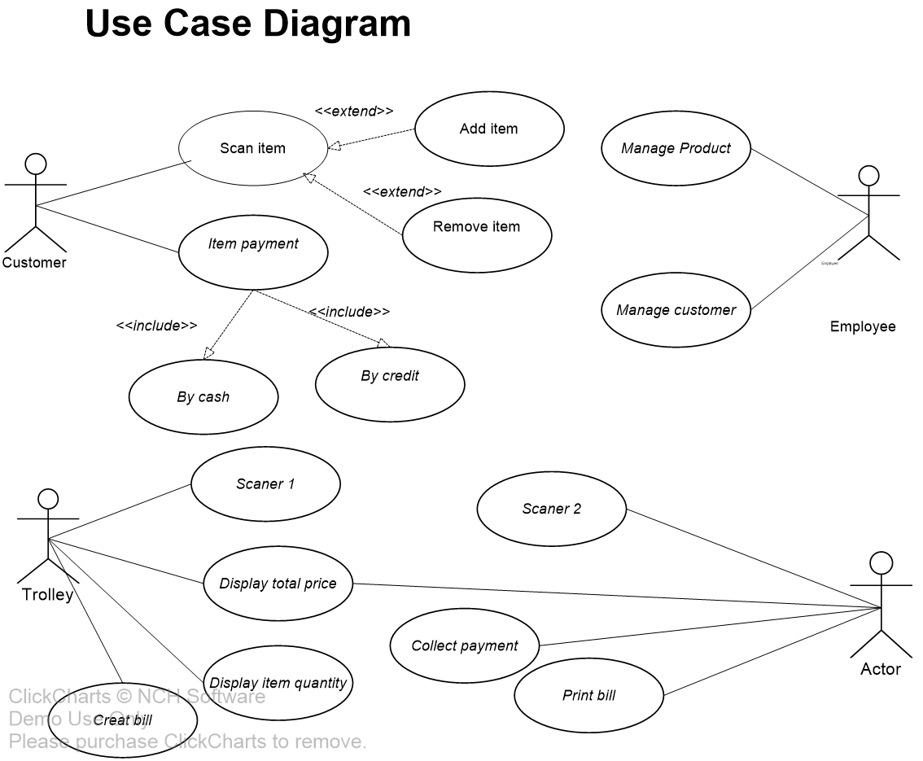

**E-R Diagram**  
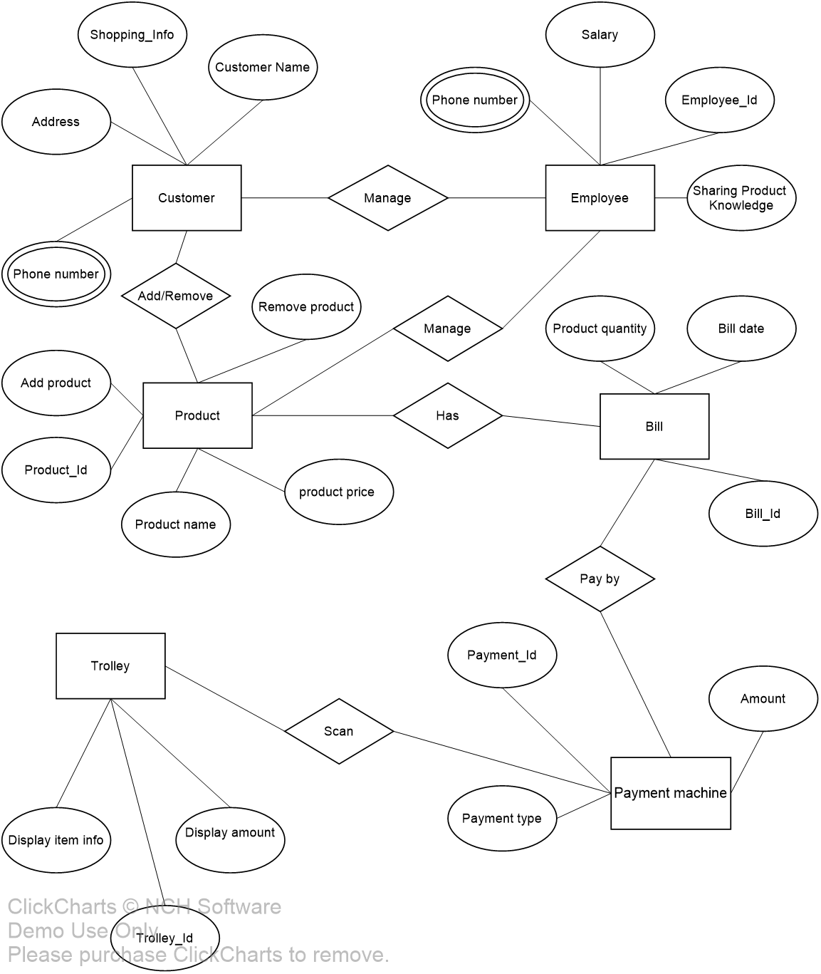

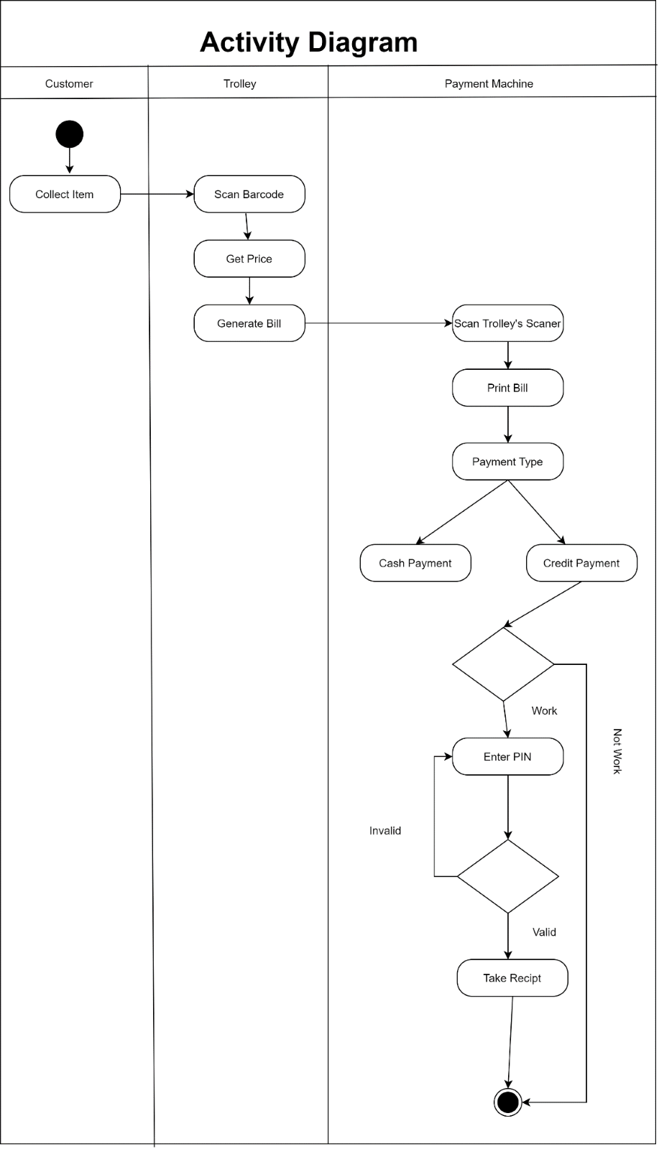

### **SOCIAL IMPACT**

Supermarket is a common place for all types people. Both technical and non-technical people gather in this place. So, this is a great scope for the society to make a common place digital. In many countries general people are using many digital technologies. Like: ticketing system in local transport services, vending machine, paying electric bill and many other purposes. So, comparing to these things, Bangladesh is quite backdated in case of using digital technology among general people. Providing this digital service will make a great opportunity to make the society digital. Also, it is beyond saying that this smart cart system saves a huge amount of time. This kind of technology is invented in some countries. Mostly the payment system is very common. But if our government wants to buy this technology and install it in our country, that would be so much expensive as well as shameful. That’s why it is best solution to make this kind of smart system in our country. And use it for our own. As customers are more likely to spend more money when utilizing the smart shopping carts, it will also enable shops to keep their shelves supplied and boost their income.

A questionnaire was made for a quick analysis on how people think about this new idea. People were explained briefly about this new tech and they were told to rate it out of 5 where,

1 = Rubbish concept

2 = Not worth it

3 = worth trying

4 = Useful

5 = Revolutionary

The survey was done with 50 random people who came lavenders supermarket for grocery shopping where 10 of them were technical persons, 10 of them were non-technical persons, 10 of them were teenagers, 10 of them were older people and the rest of them were supermarket salesmen.

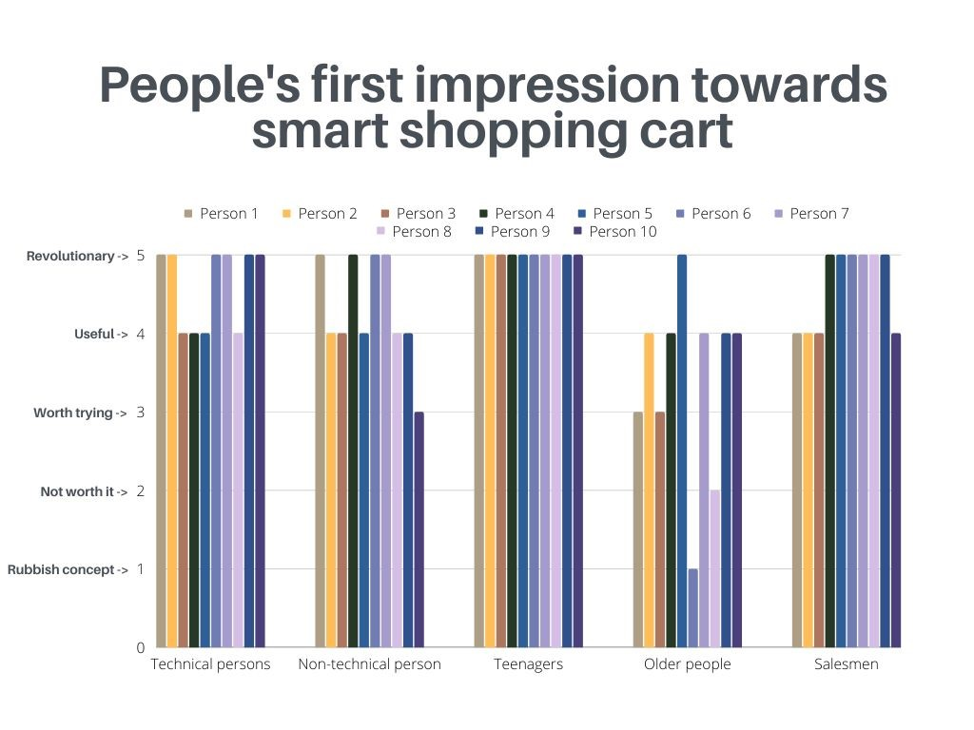From the graph, it is clear that most of the people are ready to accept this new tech in their regular life as it can be seen that people are appreciating this new idea and that’s how it’s going to make a huge social impact in our society and the people in it.

#### **DEVELOPMENT PLAN AND PROJECT SCHEDULE**

**Kick-off:** When the project Started

**Resource Mobilization:** Assign the task individually. Project manager, Business Analyst, Developers,

**Requirement Analysis:** At first, before starting the project, requirements should be collected properly. In requirements collection phase, project’s business objective, vison and scope should be clearly defined. Time to time consultation with customers is very important. Every requirement will be clearly written or mention in SRS document. According to requirements analysis, project cost, time and scope can be identified. All requirements must be feasible.

**Project Planning:** Based on SRS document software design, development process and testing process, implementation every other step can be planned. If everything is ready planned then the other processes will be done quickly and after starting the project no other stakeholders will face any problem of doing the works. Also in this phase, project developers decide which tracing tools and which testing tools will be used. So, for this project, tracing tools will be ‘Jira’ and testing tool will be ‘Selenium-Java Eclipse’.

**Documentation:** The whole process from starting to maintenance, every single action should be documented.

**System Design:** According to project plan, design user interface should be implemented. How a trolley will be looked and which components will be attached in which part of the trolley that is very important. Total components of the trolley and how the components should work.

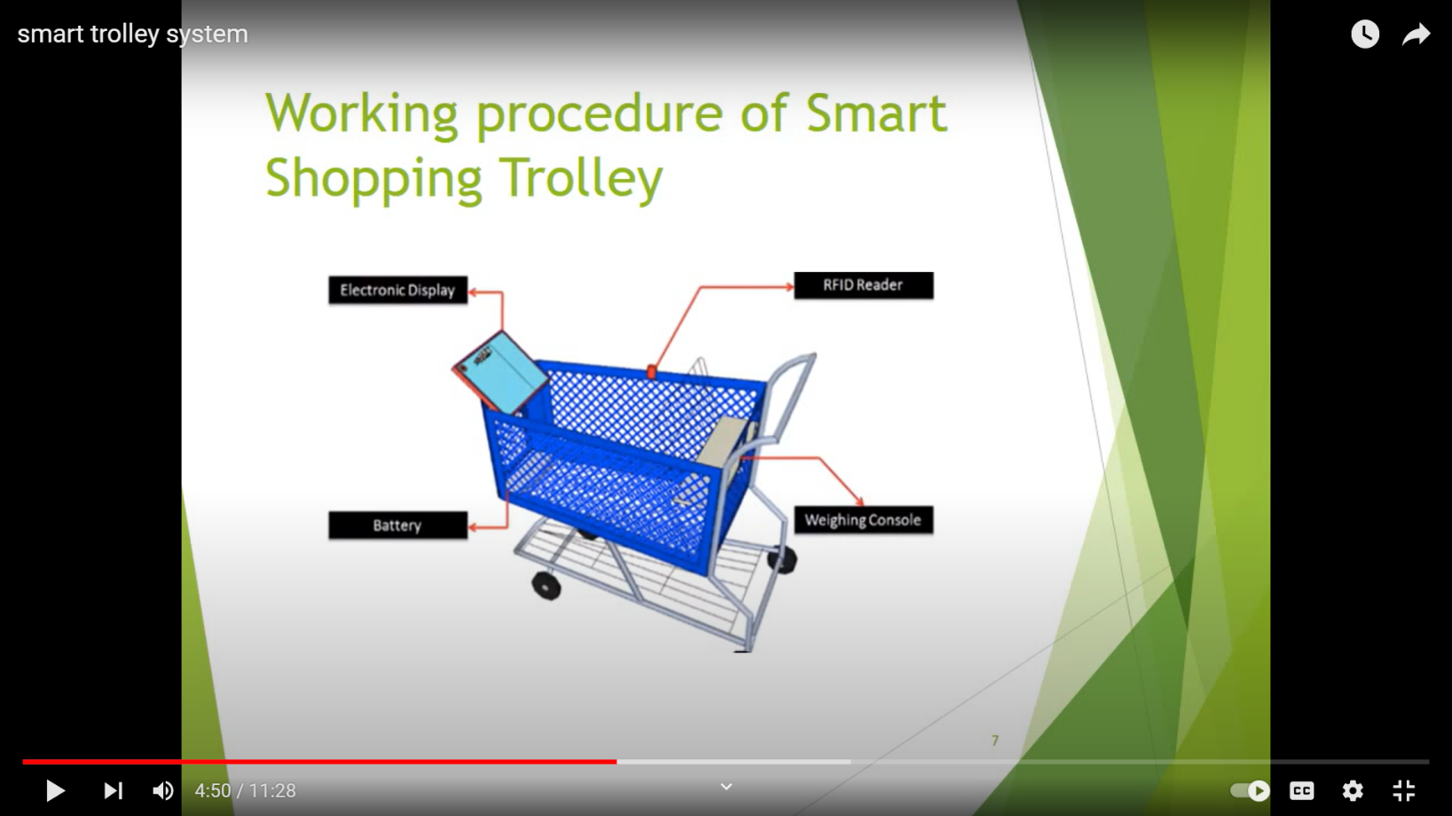***Figure: Smart Trolley Design.***

**Development:** Now developers will start working to implement the whole project. As this a microcontroller-based project, developers must be expert on microprocessor tools eg. Arduino. If SRS document is properly built then it is easy for a developer to develop the coding parts.

**Testing and Bug Fixing:** Mainly testing is a continuous process through the whole project. After one module implementation, unit testing will be done. To check the logic and path of the program, each module is tested another testing. That is control flow testing.to verify all the data, data flow testing should be implemented. After integrated all the modules, integration testing should be done to avoid all the any iteration error. After integration testing, domain testing should be done to check if the inputs can get the expected output or not. After completing the whole system, system testing should be done.

**UAT and Training:** This phase will start just after the testing phase. And it will take max 10 days.

**Deployment:** It is meaningfully the last step of development process. In this phase the whole system will be completed with quality attributes and quality factors (Maintainability, Testability, Reusability, Portability, Flexibility). Front end part will be done meaningfully and attract fully.

**Implementation:** After completing all the module and unit testing, these modules will be integrated. Also, a system can be integrated with another system. Like, after completing the trolley module, it will be integrated with payment system. And payment system is also a connection of interoperability with banking account. When customers want to pay by their cards, payment system check that specific account has enough balance or not. After verifying the account and balance. It will fulfill payment by deducting bank balance account.

**Go Live:** At last product will be finally used by the end users in market place.

##### **MARKETING PLAN**

* **Executive Summary:** D-Process Shopping Cart is a digital shopping trolley which is the fully replacement of counter system in a shopping mall and super market. This will make customers shopping easier and fun.
* **Marketing objectives:** D-Process Shopping Cart is a software-based product that makes human life easy and comfortable as well as make the shopping business more profitable. So, make this product visible to business sector and show the business benefits in the business sector by using this product ‘Marketing’ is important.
* Visualize this software product in business sector.
* Give the details information and work procedure to the consumers.
* Presenting its benefit and future goals.
* Impressing the investors for investing on our product and helping us to achieving our business goals.
* Clients’ approval for marketing plan
* Continue updating the product’s quality to maintain the highest quality product in market.
* **Business Information:** Our business type is B2B.We want to start a business by serving another business group like Store based business which serves the clients or end users that is the main target of our product business.
* 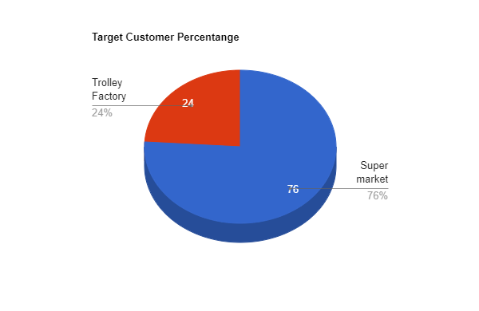**Target Customers:** Our main target customers are store shops or any other business store where payment counter and holding baskets are used. Simultaneously, some companies are already making good quality trolley or basket in their factory. And super stores buy trolley from them. So, we can make a connection with that companies that has been already providing trolleys from a long time to supermarkets. If we sell the whole trolley with advance technology, in that case our acquirer will be supermarkets. And in whole sell we will only provide the software. So, there will be two ways of customers for our business.

**Target Customers’ Percentage**

* 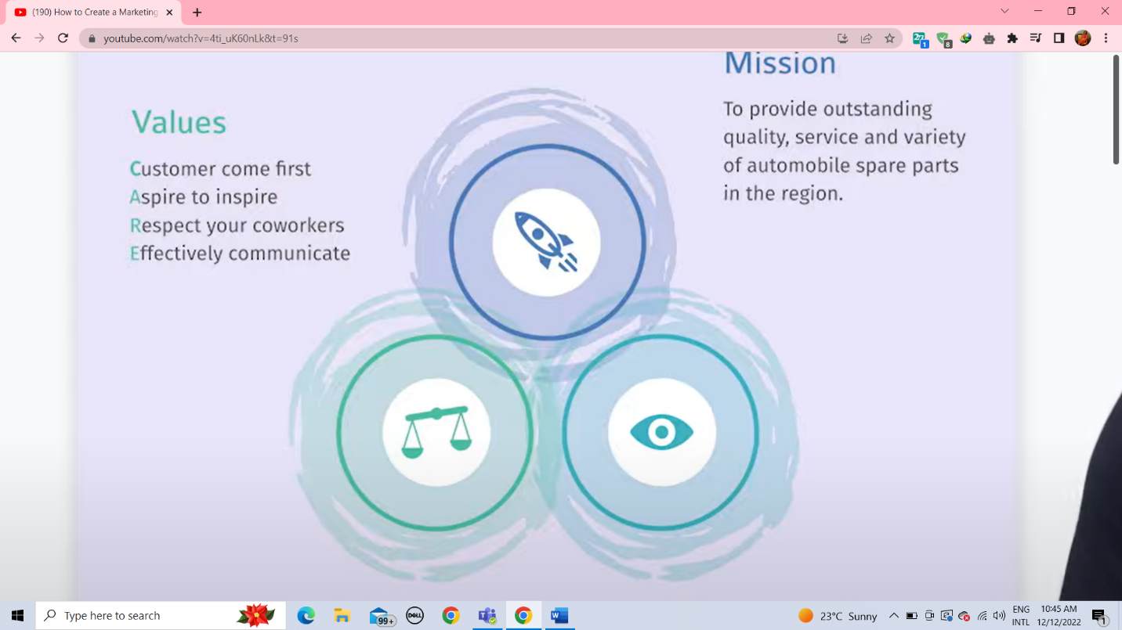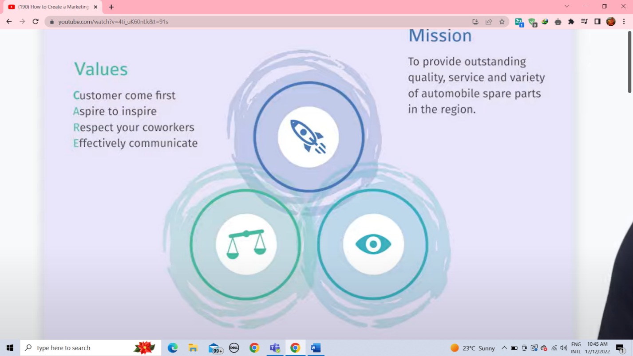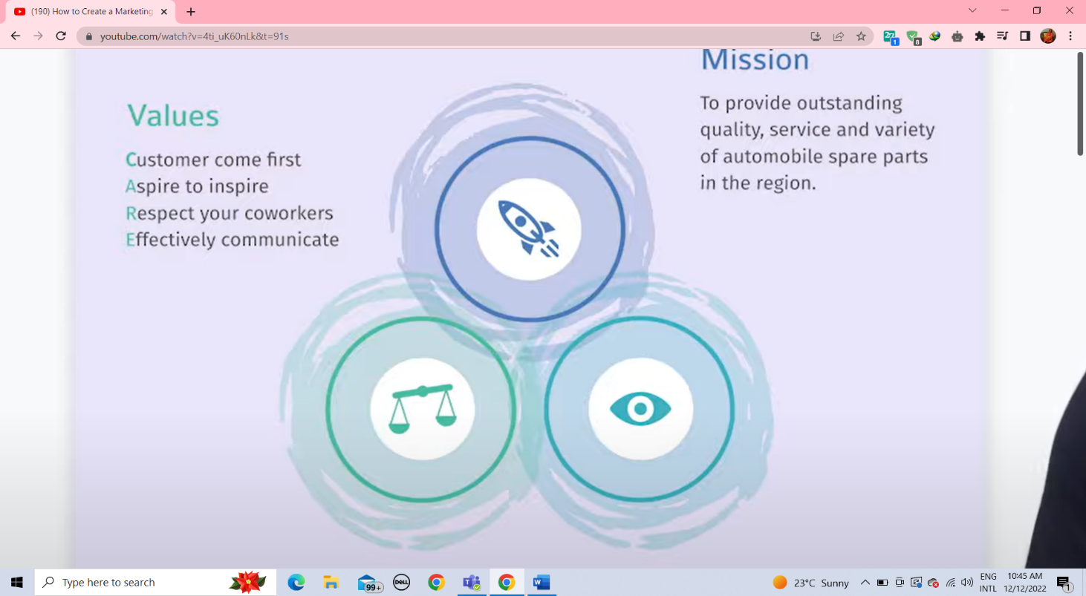**Mission, Vision and Value**

VISSION

To be the best Auto Shopping Cart and counter system in Bangladesh and spread it to the abroad

MISSION

To Make the Marketing Process Digital and Automated.

VALUE

**C**ustomers comfort comes first

**A**spire to inspire

**R**espect to Co-workers

**E**ffectively Communicate

* **SWOT Analysis**

|  |  |
| --- | --- |
| STRENGTHS | * First Automated shopping trolley in Bangladesh * Provide digital payment procedure * Ecologically Friendly Innovation * Research and Development |
| WEAKNESS | * Heavily dependent on banks in payment procedures * Slightly high cost * Need high maintenance |
| OPPOERTUNITIES | * Scope of study is huge * Easy brand made product |
| THREADS | * Easy copy * Increase Competitions |

* **Our Goals**

|  |  |
| --- | --- |
| Complete Sales minimum 1crore by 2023 | COMPLETED |
| Increase customers interest in the product |  |
| Collaborate with marketing business Company |  |

* **Marketing Goals**

|  |  |
| --- | --- |
| Pre-Launch Phase | * Increase brand awareness through social media marketing across Facebook, Linkedin and Instagram * Promote best post to reach target audience * Introduce early bird offers and deals * Offer to give the sample free to the target audience |
| Launch Phase | * Website roll-out and increase in marketing efforts to drive up sales * Send 10 samples to big supermarket and take their feedback about customers’ interest * Provide end-to-end customer service support * Mail the big company marketing to trigger engagement |
| Post-Launch | * use social media to promote the positive feedback * Encourage feedback and make improvement if any company ask to do * Make customize prototype if any company want to. |

1. **COST AND PROFIT ANALYSIS**
2. **Smart Trolley’s equipment**
   * Display

2.2inch 320x240 Touch LCD (A)

Model No: DIS-00037

Price: 924/-

(Source: techshopbd.com)

* + Four-wheel metal Shopping cart

Product code: SE 1006

Price: 6500/-

(Source: Nobarunbd.com)

* + ZKTeco CR10 RFID reader

Product ID: 47911

Price: 1800/-

(Source: bdstall.com)

* + Metal body price (Where the electrical hardwares will be installed)

Price: 1050/-

* + Arduino UNO R3

Price: 1050/-

Source: roboticsbd.com

* Lithium-ion battery

Capacity: 5500mAh

Voltage: 11.1V

Price: 4500/-

Source: startech.com.bd

* + **payment machine equipment**
    1. Metal body price (Where all the electrical hardware will be installed)

Price: 1550/-

* + 1. Display

2.2inch 320x240 Touch LCD

Model No: DIS-00037

Price: 924/-

(Source: techshopbd.com)

* + 1. Deli E14952 Handheld Barcode Scanner

Model: E14952

Input voltage: DC5VÂ± 0.5V

Data line length: 1.8m

Price: 4200/-

Source: startech.bd

* + 1. Rongta RP58E-U POS Thermal Receipt Printer

Model: Rongta RP58E-U

Paper width: 58mm

Print Speed: 100mm/sec

Print Resolution: 203 dpi

Interface: USB

Price: 4200/-

Source: startech.bd

* + 1. Credit card Reader

Payment Types: 3-in-1 (Tap, Dip, Swipe)

Price: 3658/-

Source: fitsmallbusiness.com

**Total Components’ cost: 30356**

**Client cost**

Working days: 22days

Project duration: 10 months

Total Working Days: 22*10 =220Days

With all holidays Total Working days: 185 Days

Server Cost: 1000000/=

Others (Utility, Wifi, Devices charge, Transport): 500000/=

Workers per day Salary:

|  |  |  |
| --- | --- | --- |
| **Role** | **Salary/Man Day** | 10223*185=1891255  1891255+1000000+500000=3391255  With 5% Vat  Total Cost: 3560818/=  With Component cost: 3591174 |
| Project manager | 14000 |
| Business analyst | 12000 |
| Solution Architect | 12000 |
| Database Admin | 9000 |
| Senior developer | 10000 |
| Front End developer | 8000 |
| Back End developer | 8000 |
| QA | 9000 |
| Trainer | 10000 |
| **Total** | **92000** |
| **Average** | **10223** |

**Actual Cost:**

Project Duration: 9 months

Server cost: 600000/=

Others (Utility, Wifi, Devices charge, Transport): 300000/=

Workings of workers

|  |  |
| --- | --- |
| **Role** | **Working Days** |
| Project manager | 150 |
| Business analyst | 60 |
| Solution Architect | 35 |
| Database Admin | 30 |
| Senior developer | 50 |
| Front End developer | 60 |
| Back End developer | 90 |
| QA | 35 |

**Actual Salary:**

|  |  |  |
| --- | --- | --- |
| **Role** | **Salary** | 7500*150=1125000  1125000+600000+300000=2025000/=  With 5% vat  Total Cost: 2126250/=  With Components cost: 2156606/= |
| Project manager | 10000 |
| Business analyst | 9000 |
| Solution Architect | 9000 |
| Database Admin | 6000 |
| Senior developer | 8000 |
| Front End developer | 6000 |
| Back End developer | 6000 |
| QA | 6000 |
| **Total** | **60000** |
| **Average** | **7500** |

**Profit:** Total Cost of client Price- Total cost of Actual Price

3560818-2126250 = 1434568

1. **REFERENCES**

* [**https://www.researchgate.net/publication/280721277_Smart_Trolley**](https://www.researchgate.net/publication/280721277_Smart_Trolley)
* [**https://www.youtube.com/watch?v=iLHyTLS8dWo**](https://www.youtube.com/watch?v=iLHyTLS8dWo)
* [**https://superhii.com/news/smart-shopping-trolley-p2.html**](https://superhii.com/news/smart-shopping-trolley-p2.html)
* [**https://ukdiss.com/examples/smart-trolley-system-automated-billing.php**](https://ukdiss.com/examples/smart-trolley-system-automated-billing.php)
* [**https://www.youtube.com/watch?v=4ti_uK60nLk&t=91s**](https://www.youtube.com/watch?v=4ti_uK60nLk&t=91s)